F:\Scanned\20141210093339337_0001.tif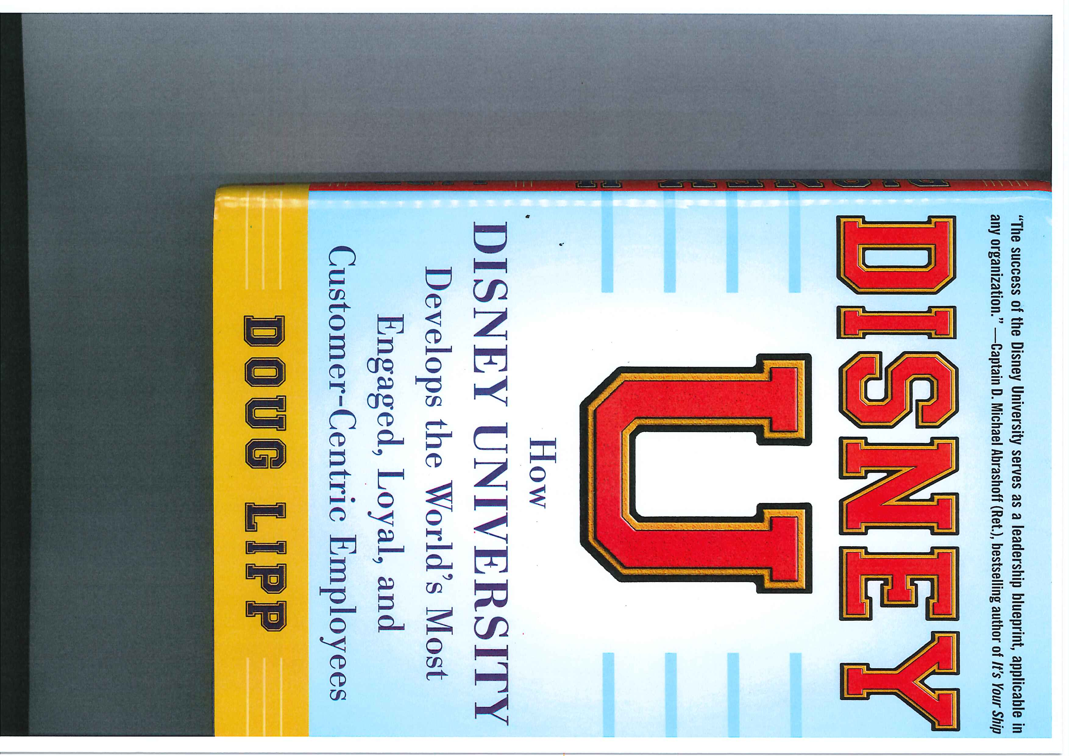

F:\Scanned\20141210093339337_0002.tifF:\Scanned\20141210093339337_0002.tif

F:\Scanned\20141210093339337_0003.tifF:\Scanned\20141210093339337_0003.tif

F:\Scanned\20141210093339337_0004.tifF:\Scanned\20141210093339337_0004.tif

F:\Scanned\20141210093339337_0005.tifF:\Scanned\20141210093339337_0005.tif