Week 2 Exercise 15, 16 Worksheet
Exercise 15
Why is Voltage Drop important?

List three factors that would increase Voltage Drop.
1.
2.
3.

Calculate the voltage drop in this example from the video, as a percentage of the nominal voltage at the point of supply.

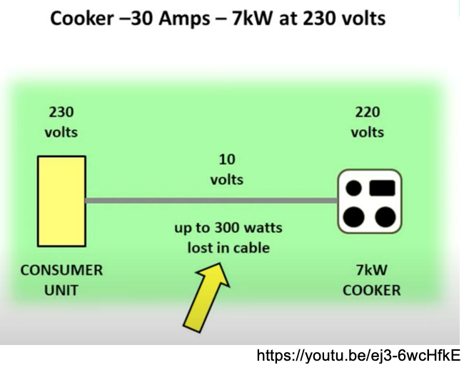

Exercise 16
Use the formula above and the values from Table C8 to answer the following questions.

- Calculate the percentage voltage drop in a 50m run of 16mm² cable carrying three-phase (400V) 32A.

- Calculate the smallest suitable cable conductor size required in a 125m run of cable carrying three-phase (400V) 80A.

Did you calculate answers of 0.97% (2 d.p.) and 25mm² ?
What would your answer to Question 1 be if the supply was single-phase 230V?

