**Week 3 Worksheet Answers**

Exercise 12

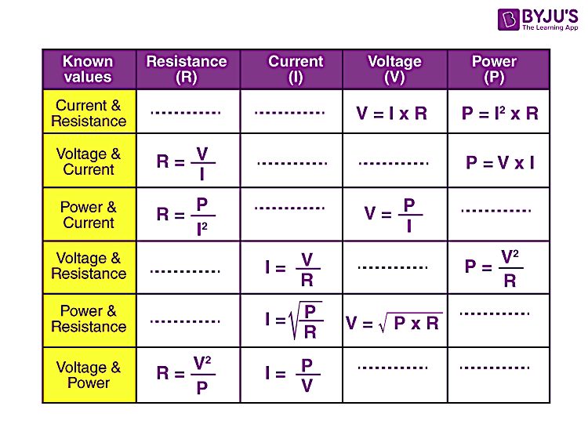

Exercise 13

### What is the equation for power?

V = IR

P = IV

P = IR

P = I/V

### What is the unit of electrical power?

watt

volt

ampere

ohm

### What will be the current drawn by an electric bulb of 1000 W when it is connected to a source of 220 V?

4.55 A

28800 J or 28.8 KJ

80 W

200 W

### A current of 4 A flows through a 20 V car headlight bulb. Calculate the electric power.

80 W

200 W

2.5 A

4.55 A

### Calculate the electric power of an electrical appliance in which 10 A of current is flowing through a resistor of 2 ohms.

80 W

200 W

2.5 A

22.5 KJ

### Calculate the electric power of an electrical appliance of 20 V having a resistance of 10 ohms.

200 W

40 W

2.5 A

79.20 KJ

### A pair of 15-watt computer speakers are connected to a 12-volt power supply. What is the electric current running through the speakers?

1.25 A

0.8 A

12.5 A

180 A

### How many amps are in 800mA?

800,000 A

8 A

0.8 A

80 A

### If the ammeter shows a reading of 997 mA, how many amps of current is flowing through the circuit?

997 A

99.7 A

9.97 A

0.997 A

### When measuring a circuit you get a voltmeter reading of 3 volts and an ammeter reading of 600 mA. What is the power being supplied to the device?

1.8 W

1800 W

0.005 W

5 W

What is the power dissipated by an electric light filament of resistance 2.0 ohms if a potential of 12 volts is maintained across the terminals?

6.0 watts

48 watts

24 watts

72 watts

How much current is used in a 60 W, 240 V light globe?

0.25A

4A

15A

960 A

Exercise 15

