**Lesson 6 - Self-directed Learning**

A student has a resistor of unknown resistance. She places the resistor in series with a power source of variable potential difference. Using an ammeter, she measures the current through the resistor and voltage across the resistor.

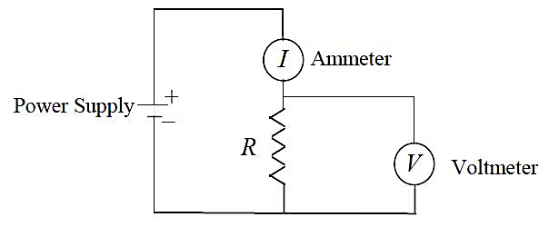

Her results look like this:

|  |  |  |  |  |  |  |  |  |
| --- | --- | --- | --- | --- | --- | --- | --- | --- |
| Current (A) | 0.22 | 0.47 | 0.85 | 1.05 | 1.50 | 1.80 | 2.00 | 2.51 |
| Voltage (V) | 0.66 | 1.42 | 2.54 | 3.16 | 4.51 | 5.41 | 5.99 | 7.49 |

Plot these figures on the following graph.

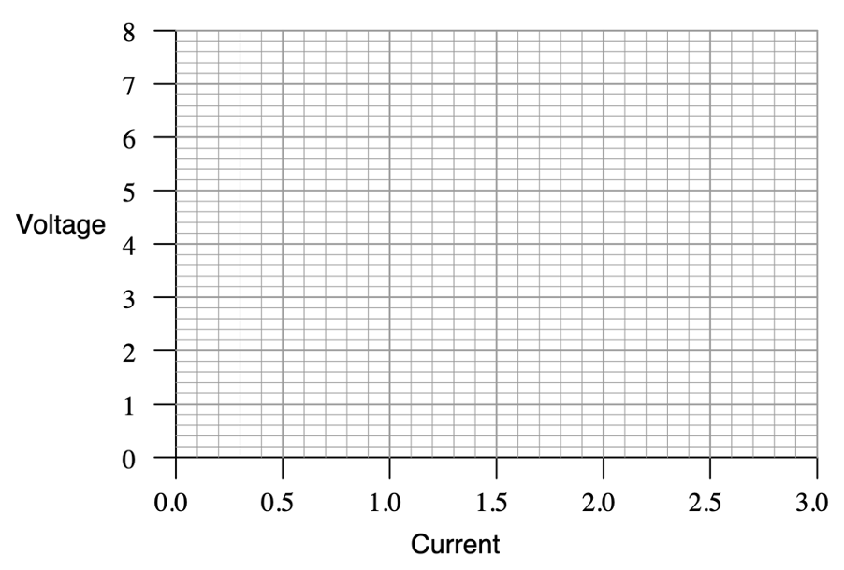

What mathematical relationship do you see between voltage and current in this simple circuit? How could you calculate resistance from the graph?