Lesson 11 SDL
Fill in the table once you complete each circuit. (Don’t leave it until the end!)
When you have completed all six circuits, summarise your findings.

RESULTS TABLE
Circuit | Brightness of  Bulb A | Brightness of  Bulb B | Brightness of  Bulb C
1 Bulb - Series | 3 | - | -
2 Bulbs - Series |  |  | -
3 Bulbs - Series
2 Bulbs - Parallel |  |  | -
3 Bulbs - Parallel
Combined

INSTRUCTIONS
- Begin by building the simplest of circuits using the battery, one light bulb, and the switch, along with necessary wires to make the connections. Close the switch and observes what happens. | 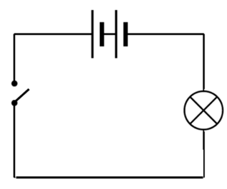
- Continue by building both series circuits shown below. Close the switch and observe what happens. Rank the brightness of the bulbs - with 3 representing the brightest and 1 representing the dimmest. | 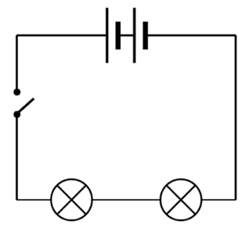
 | 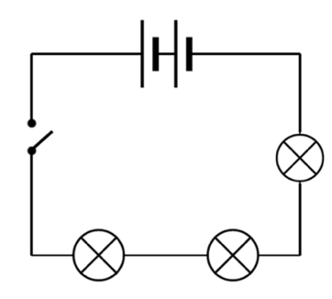
- Return to your original circuit and add a second bulb in parallel with the original as shown below. Close the switch, observe what happens, and rank the brightness of the bulbs in your table. | 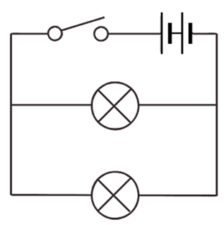
- Add a third bulb in parallel as shown. Close the switch, observe what happens, and rank the brightness of the bulbs in your table. | 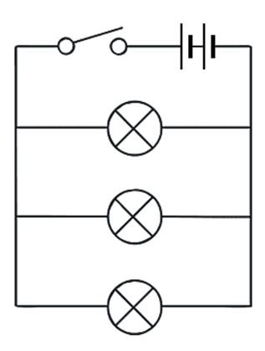
- Finally, build the three-bulb combined circuit shown below. Again, close the switch, observe what happens, and rank the brightness of the bulbs in your table. | 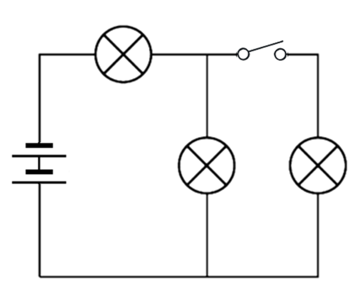
Questions to answer:

- Describe the differences between a closed and an open circuit.

- What do you notice about the brightness of the bulbs in the series circuits as you added more bulbs to it?

- What do you notice about the brightness of the bulbs in the parallel circuits as you added more bulbs to it?

- How does removing a bulb or opening and closing the switch affect a series circuit?

- How does removing a bulb or opening and closing the switch affect a parallel circuit?

