Electric Motor Vs Generator Worksheet

How does an electric motor differ from a generator? Compare them using a Venn Diagram, choosing your answers from the box below. Download a copy of the worksheet to write your answers into.

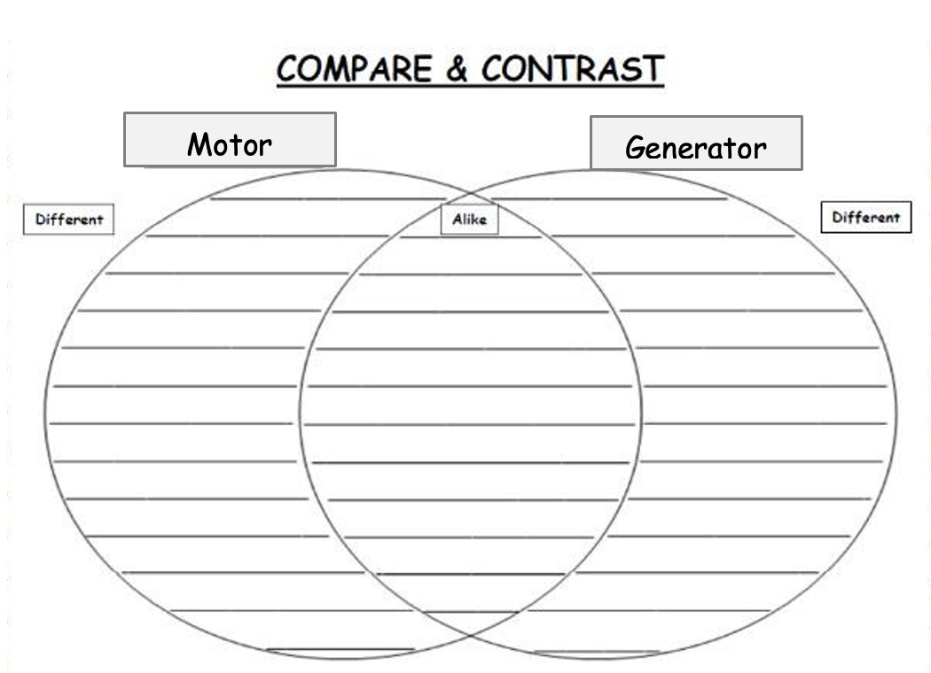

input is mechanical | have stator and rotor | electromagnetic induction
electric fan | permanent magnet | converts electrical energy to mechanical energy
power turbine | coil mounted on axle with a magnetic field | input is electrical
energy transformation | converts mechanical energy to electrical energy | generates electricity
magnetic force | electric car or bike | have coil of wire

