**Course 3 Week One Answers**

**Lesson 1**

Exercise 2.10

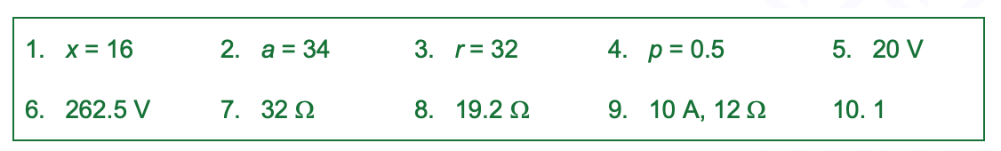

**Lesson 2**

Exercise 4.1

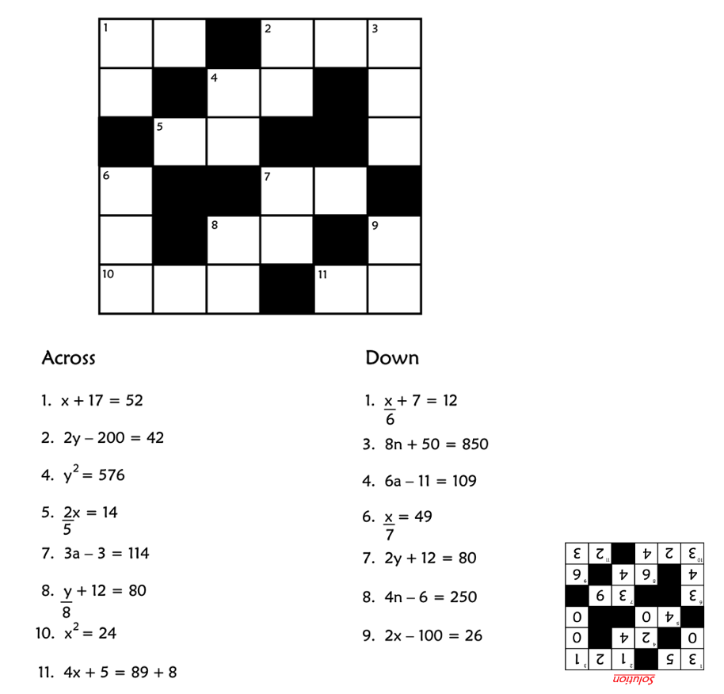

**Lesson 3**

Basic calculations

### Use your calculator to work out the answers to the following calculations and check you get the correct answer.

### 3298 + 76 x 258 = 22,906

### 4644 ¸ 86 – 19 = 35

### 65 x (3106 – 999) = 136,955

### (98,352 + 321) x (63,051 – 49,872) = 1,300,411,467

Exponents and roots

### Use your calculator to work out the answers to the following calculations and check you get the correct answer.

### 3452 = 119,025

### 86 = 262,144

### 93 – 39 = -18,954

### Use your calculator to work out the answers to the following calculations and check you get the correct answer.

### $\sqrt{600.25}$ = 24.5

### $\sqrt[3]{4913}$ = 17

### $\sqrt[6]{729}$ = 3

### Scientific notation on your calculator

### Use your calculator to work out the answers to the following calculations and check you get the correct answer.

### 0.68 x (4.6 x 107) = 3.128 x 107 or 31,280,000

### (7.5 x 1012) ¸ (3.2 x 106) = 2.34375 x 106 or 2,343,750

### (4 x 10-3) + (5 x 10-4) = 4.5 x 10-3 or 0.0045

Fractions and decimals

### Use your calculator to work out the answers, in both fractional and decimal forms, to the following calculations. Check you get the correct answer.

### 468 ¸ 585 = $\frac{4}{5}$ or 0.8

### 3654 ¸ 252 = 14 $\frac{1}{2}$ or 14.5

### 16.125 x 3.02 = 48 $\frac{279}{400}$ or 48.6975

SDL

<https://corbettmaths.com/wp-content/uploads/2015/03/use-of-a-calculator.pdf>

<https://corbettmaths.com/wp-content/uploads/2015/03/standard-form.pdf>